Offshore Habitat Assessment for US Wind Energy

Benjamin D. Best

2023-10-19

Contents

Preface 3

1. Abstract 3

2. Introduction 3

3. Methods 4

3.1 Spatial Hierarchy: Regions > Zones > Blocks 5

3.1.1 Regions and Zones 5

3.1.2 Blocks 6

3.2 Datasets 6

3.3 Processing Steps 7

3.4 Scoring Conservation Value 9

3.5 Normalizing within Zone for Block Comparison 9

3.6 Reproducible Science 10

4. Results 10

5. Discussion 19

References 19

Appendix A — Species 22

All Species in Study Area 22

Treemap 22

Table 23

Species with Extinction Risk 25

Treemap 25

Table 26

Appendix B — Scoring 28

Score 28

Pixel Values 28

Zone Averages 29

Species Richness 30

Pixel Value 30

Zone Average 31

Species Abundance 32

Pixel Value 32

Zone Average 33

Extinction Risk 34

Pixel Value 34

Zone Average 35

Primary Productivity 36

Pixel Value 36

Zone Average 37

Hydrothermal Vents 38

Pixel Value 38

Zone Average 39

Seamounts 40

Pixel Value 40

Zone Average 41

Appendix C — Blocks 41

C.1 Zones with Blocks 41

Washington/Oregon 42

Northern California 43

Central California 44

Southern California 45

Western Gulf of Mexico 46

Central Gulf of Mexico 47

South Atlantic 48

Mid Atlantic 50

North Atlantic 52

# Preface

This report was funded by the [Resources Legacy Fund](https://resourceslegacyfund.org/).

This report is available also as an online interactive report (.html):

* [offshorewindhabitat.info/report](https://offshorewindhabitat.info/report)

# 1. Abstract

Development of offshore wind energy will be essential for providing renewable energy to mitigate climate change impacts. Analysis of habitats and species in call and lease areas can allow for responsible siting that minimizes impacts on sensitive species and habitats and present opportunities for sensitive habitat protections within lease areas. The Bureau of Ocean Energy Management (BOEM) manages the federal offshore leasing of wind energy for the United States (U.S.) and has defined regions, zones and individual lease blocks, which were used to evaluate differences in species and habitats for the federal waters of the contiguous U.S. (excluding Alaska and Hawaii). In order to combine species distribution models (SDMs) from varying sources, they needed to be harmonized according to: 1) a common taxonomy, using the AphiaID from the World Register of Marine Species (WoRMS) at [MarineSpecies.org](https://MarineSpecies.org); 2) a common geography, using the most refined available global bathymetric raster, the General Bathymetric Chart of the Oceans (GEBCO) at [GEBCO.net](https://www.gebco.net); and 3) a common response term. The harmonized response term rescaled input SDMs 0 to 100 according to a preferred hierarchy of available models for the same species: 1) density surface models, where the original response was # individuals / km2 for 151 species of marine mammals, seabirds and sea turtles across 4 datasets; 2) habitat suitability models, which had a continuous response of 0 to 1 for 9,639 species from [AquaMaps.org](https://www.aquamaps.org); and 3) expert range maps with a binary response of 0 or 1 for 342 species from the [IUCN Red List](https://www.iucnredlist.org/resources/spatial-data-download). From the combined SDMs, species richness and species abundance were calculated per pixel along with an aggregate extinction risk for those species having an IUCN Red List category assigned. An overall conservation score also incorporated primary productivity, hydrothermal vents and seamounts with equal weighting for each layer. These scores were calculated on a per pixel basis as well as aggregated to zone and region levels. At the block level, the standard deviation from the zone’s mean score was calculated to differentiate and rank blocks.

# 2. Introduction

Development of offshore wind energy will be essential for providing renewable energy to mitigate climate change impacts. Analysis of habitats and species in call and lease areas can allow for responsible siting that minimizes impacts on sensitive species and habitats and present opportunities for sensitive habitat protections within lease areas. Acoustic impacts from construction and operation may negatively impact some species (Mooney, Andersson, and Stanley 2022). Hard substrate provided by the platforms may actually benefit other species (Wilson and Elliott 2009). Although only 42 megawatts (MW) of offshore wind energy capacity is operational (in Rhode Island and New York) as of May 31, 2022, the pipeline of potential generating capacity is estimated to be 40 gigawatts (GW) – enough to power 13 million homes (Musial et al. 2022).

Wind energy areas are under active development by the Bureau of Ocean Energy Management (BOEM) throughout the U.S. This report assesses habitats for sensitivity throughout the federal waters of the contiguous U.S. lower 48 states (excluding Alaska and Hawaii).

A couple of fundamental questions driving this analysis include:

1. *How different are zones (and regions)?* (***inter-zone/region***)  
   Areas not already slated for the offshore wind leasing impact species and habitats less, so could be candidates for alternative future planning. Areas with designated military use and outside BOEM’s authority (e.g., National Marine Sanctuaries) need to be further excluded from consideration.
2. *How different are blocks from each other within a given region?* (***inter-block***, ***intra-zone***)  
   Within the leasing process, the most oversight can be exercised within existing lease areas, especially ones in the earlier stages of Proposed Sale Notices and Call Areas. Blocks within the same zone highlight where the most conservation value exists relative to each other.

While density surfaces are most preferable, especially for determining number of individuals impacted by human activity (e.g., for Potential Biological Removal as mandated by the Marine Mammal Protection Act (Roman et al. 2013)), the distributions of relatively few taxa have been described by these model types. The most comprehensive atlas of marine species distributions comes from the AquaMaps (Kaschner et al. 2019), which uses only 4 terms per environmental predictor (min, max and preferred min and max) to produce a gradient of habitat suitability (Ready et al. 2010). Yet another type of distributional information is based on a binary range map, such as produced by taxonomic experts with the IUCN RedList process.

Collating the best available data has been a significant challenge to date and has become all the more important with the global push for 30% conservation protection of land and sea by 2030 with the Kunming-Montreal Global Biodiversity Framework resolution passed at the Convention of Biological Diversity meeting in Montreal in December 2022 (Findlay 2023). Although the U.S. was notably absent from the 190 signatory countries, President Biden has advocated for similar protections nationally through the “America the Beautiful” initiative. The lack of comprehensive biodiversity information has been noted (Carroll, Noss, and Stein 2022).

# 3. Methods

In order to assess species and habitats across the federal waters of the contiguous U.S. (excluding Alaska and Hawaii), the spatial reporting units were setup based on BOEM planning areas dubbed “Zones” in this report and overall regions were first clipped to the United States Exclusive Economic Zone (EEZ) (Figure 3.1).

## 3.1 Spatial Hierarchy: Regions > Zones > Blocks

Determination of regions for which to assess offshore habitat was based on BOEM activity and representativeness of habitats across the continental United States (Figure 3.1). The first (and presently only commercially in production) U.S. wind farm at Block Island, NJ is in the North Atlantic where $4.4 billion was paid in offshore wind bids earlier this year ([DOE news](https://poweralliance.org/2022/02/25/boem-sets-offshore-energy-records-with-4-37-billion-in-winning-bids-for-wind-sale/)). The Atlantic seaboard slopes gradually making it appropriate for fixed platforms, whereas the Pacific coast drops off quickly into deeper depths making floating platforms more suitable. These technological differences therefore affect the bottom habitats differently. Whereas fixed platforms involve pile driving and addition of hard surfaces for habitats, the floating platforms leave only the benthic footprint of moorings and submarine cables.

### 3.1.1 Regions and Zones

|  |
| --- |
| Figure 3.1: Regions (Atlantic, Gulf of Mexico, and Pacific) are subdivided into Zones corresponding to BOEM Planning Areas in federal waters clipped to the U.S. Exclusive Economic Zone (except Alaska and Hawaii). To prevent overcrowding of labels only abbreviations are shown for Central (CGM), Eastern (EGM) and Western (WGM) Gulf of Mexico. Please also see the [online interactive figure](https://offshorewindhabitat.info/report/methods.html#fig-map-zones). |

### 3.1.2 Blocks

Table . Summary of Blocks per Zone, grouped by Region.

| Zone | # of Blocks | Block Area (km^2^) |
| --- | --- | --- |
| Atlantic | | |
| Mid Atlantic | 2,526 | 13,506 |
| North Atlantic | 6,367 | 48,092 |
| South Atlantic | 801 | 3,448 |
| Gulf of Mexico | | |
| Central Gulf of Mexico | 18 | 416 |
| Western Gulf of Mexico | 96 | 2,215 |
| Pacific | | |
| Central California | 16 | 23 |
| Northern California | 237 | 535 |
| Southern California | 673 | 2,590 |
| Washington/Oregon | 1,267 | 5,423 |

## 3.2 Datasets

In order to combine species distribution models (SDMs) from varying sources, they needed to be harmonized according to: 1) a common taxonomy, using the AphiaID from the World Register of Marine Species (WoRMS) at [MarineSpecies.org](https://MarineSpecies.org); 2) a common geography, using the most refined available global bathymetric raster, the General Bathymetric Chart of the Oceans (GEBCO) availalbe at [GEBCO.net](https://www.gebco.net); and 3) a common response term.

The harmonized response term rescales input SDMs 0 to 100 according to a preferred hierarchy of available models for the same species: 1) density surface models, where the original response was # individuals / km2 for 151 species of marine mammals, seabirds and sea turtles across 4 datasets; 2) habitat suitability models, which had a continuous response of 0 to 1 for 9,639 species from [AquaMaps.org](https://www.aquamaps.org); and 3) expert range maps with a binary response of 0 or 1 for 342 species from the [IUCN Red List](https://www.iucnredlist.org/resources/spatial-data-download).

From the combined SDMs, species richness and species abundance were calculated per pixel along with an aggregate extinction risk for those species having an IUCN Red List category assigned. An overall conservation score also incorporated primary productivity, hydrothermal vents and seamounts with equal weighting for each layer. These scores were calculated on a per pixel basis as well as aggregated to zone and region levels. At the block level, the standard deviation from the zone’s mean score was calculated to differentiate and rank blocks.

Table . Summary of datasets.

|  |  |  |  |  |  | Regions | | |
| --- | --- | --- | --- | --- | --- | --- | --- | --- |
| Key | Name* | Type | Taxa | # Taxa | Year | Pacific | Atlantic | GoMex |
| am | AquaMaps Global Probabilities | probability | All | 9,639 | 2021 | ✓ | ✓ | ✓ |
| rl | IUCN Global RedList Ranges | range | All | 342 | 2022 | ✓ | ✓ | ✓ |
| du | Duke Atlantic Marine Mammal Densities | density | Marine mammals | 48 | 2022 |  | ✓ | ✓ |
| sw | SWFSC Pacific Cetacean Densities | density | Marine mammals | 13 | 2020 | ✓ |  |  |
| gm | NOAA GoMex Cetacean & Sea Turtle Densities | density | Marine mammals, sea turtles | 11 | 2022 |  |  | ✓ |
| nc | NCCOS Atlantic & Pacific Seabird Densities | density | Seabirds | 79 | 2021 | ✓ | ✓ |  |
| sm | SOEST Pacific Seamount Occurrences | occurrence |  |  | 2011 | ✓ |  |  |
| ve | InterRidge Pacific Hydrothermal Vent Occurrences | occurrence |  |  | 2020 | ✓ |  |  |
| vg | OregonState Global Productivity | productivity |  |  | 2021 | ✓ | ✓ | ✓ |

* Dataset citations:

* AquaMaps Global Probabilities (Kaschner et al. 2019)
* IUCN Global RedList Ranges (IUCN (International Union for Conservation of Nature) 2022)
* Duke Atlantic Marine Mammal Densities (Roberts et al. 2016)
* SWFSC Pacific Cetacean Densities (Becker et al. 2020)
* NOAA GoMex Cetacean & Sea Turtle Densities (Litz et al. n.d.)
* NCCOS Atlantic & Pacific Seabird Densities [leirnessNCCOSAssessmentModeling2021;Winship et al. (2018)]
* SOEST Pacific Seamount Occurrences (Kim and Wessel 2011)
* InterRidge Pacific Hydrothermal Vent Occurrences (Beaulieu and Szafrański 2020)
* OregonState Global Productivity (Behrenfeld and Falkowski 1997) ([sites.science.oregonstate.edu/ocean.productivity](http://sites.science.oregonstate.edu/ocean.productivity))

## 3.3 Processing Steps

1. **Download datasets**  
   Datasets were downloaded from their online sources and chosen based on availability throughout the EEZ of one or more of the U.S. regions (i.e., Pacific, Gulf of Mexico and/or Atlantic).
2. **Convert dataset layers to common raster format**  
   In order to calculate quickly across a wide range of spatial data based on different formats (vector or raster), spatial units of analysis and projections, a common study area and grid was generated from the **GEBCO** bathymetric grid at 15 arc second spatial resolution and projected to Web Mercator for readily displaying in “slippy” maps online to easily show basemaps of interest (e.g. the Esri Ocean basemap). The area-based distortion of Web Mercator was compensated for by calculating the true area per cell as a separate layer for deriving the area-weighted average in the output cells. All data layers were downscaled to a common grid of approximately 15 arc-seconds (each pixel ranging in area 0.16 to 0.31 km2) aligned with the GEBCO high resolution global bathymetry in order to calculate differences between individual lease blocks (ranging in area 0.022 to 276.186 km2).
3. **Average within dataset-species layers**  
   Some datasets include seasonally (e.g., “Duke Atlantic Marine Mammal Densities) or regionally (e.g.,”NCCOS Atlantic & Pacific Seabird Densities”) distinct density surfaces. These get averaged (for seasonal) and mosaicked (for regional) together to produce a single average per dataset and species.
4. **Rescale dataset-species layers 0 to 100% for all model types**  
   While this analysis is detailed spatially, it is coarse in terms of abundance, since the best available spatial distribution information is combined across disparate dataset types (seeTable 2), i.e. expert ***range*** maps (i.e., “IUCN Global RedList Ranges”), ***suitability*** of occurrence (i.e., “AquaMaps Global Probabilities”) and ***density*** surface models (e.g., “Duke Atlantic Marine Mammal Densities”, “SWFSC Pacific Cetacean Densities”, “NCCOS Atlantic & Pacific Seabird Densities”, “NOAA GoMex Cetacean & Sea Turtle Densities”). Model values were rescaled 0 to 100%, i.e. normalized to the existing suitability of occurrence range of values, similar to the dataset “AquaMaps Global Probabilities”. For instance, the original maximum ***density*** surface model value for common dolphins (*Delphinus delphis*) in the Atlantic from “Duke Atlantic Marine Mammal Densities” is 286 individuals per km2, whereas for the minke whale (Balaenoptera acutorostrata) in the Pacific from “SWFSC Pacific Cetacean Densities” is 0.00491 individuals per km2. Both of these maxima are converted to 100, since we are not comparing relative abundance between species but rather within species. Since expert ***range*** maps are binary in nature, i.e. in or out of range, a single value of 50% is applied within the range. Converting the stored values to single unsigned integers (INT1U for the range [0, 100]) enables a significant reduction of individual raster file sizes. Furthermore, zeros were converted to NA (not available) for the sake of calculating the species range. A similar hierarchy was taken for “Biologically Important Areas to Cetaceans” in the US (LaBrecque et al. 2015).
5. **Mosaic to single taxa across datasets, taxa**  
   Since some datasets were not present in all regions, a mosaic approach was taken whereby different datasets could contribute to different regions, based on which had the most preferred data type (***density*** > ***suitability*** > ***range*** > ***occurrence***) and most recently collected (***newer*** > ***older***). Of 10,061 species, only 41 had multiple datasets contributing to different regions.
6. **Aggregate layers to use as inputs to scoring**  
   **Species Richness** was calculated as the sum of the presence of taxa in a given pixel. **Species Abundance** was the sum of the normalized abundance (ranging 1 to 100) within the pixel across all species. **Extinction Risk** was based on the sum of all species IUCN RedList Categories for the given pixel, based on conversion of the categories to a score: 0 for Least Concern (LC), 1 for Near Threatened (NT), 2 for Vulnerable (VU), 3 for Endangered (EN) and 4 for Critically endangered (CR) [Juslén et al. (2016);butchartImprovementsRedList2007].
7. **Score with input layers**  
   Calculate the score per pixel with the input aggregate layers using Equation 3.1.
8. **Extract across spatial hierarchies**  
   Average zonal statistics were then captured across the full spatial hierarchy of Study, Regions, Zones and Blocks.
9. **Normalize Block scores**  
   In order to easily compare Blocks within a Zone, pixel and Block scores were subtracted from the Zone mean and divided by the standard deviation (Equation 3.2). This way pixels and Blocks equal to the mean will be 0, positive values containing higher conservation scores, negative values lower conservation scores.

## 3.4 Scoring Conservation Value

By combining disperate layers with weights we can arrive at a fundamental conservation index (O’Hara and Halpern 2022).

$$\begin{matrix} & rescale\left(x\right)=\left[x-min\left(x\right)\right]/\left[max\left(x\right)-min\left(x\right)\right] \\ & \\ & Score_{raw}=w_{SR}*rescale\left(SpeciesRichness\right) \\ & +w_{SA}*rescale\left(SpeciesAbundance\right) \\ & +w_{ER}*rescale\left(ExtinctionRisk\right) \\ & +w_{PP}*rescale\left(PrimaryProductivity\right) \\ & +w_{HV}*rescale\left(HydrothermalVents\right) \\ & +w_{S}*rescale\left(Seamounts\right) \\ & \\ & Score=rescale\left(Score_{raw}\right)*100\end{matrix} \left(3.1\right)$$

The $HydrothermalVents$ and $SeaMounts$ layers are presence-only (i.e., binary, 1 or 0), so convert to a value of 0.5 where present, whereas the other layers have a range from 0 to 1.

A naive weighting approach is taken in which all weights $w$ are given an identity value of 1. To allow different value sets among users, a useful future application would calculate new scores based on expert-weighted values.

## 3.5 Normalizing within Zone for Block Comparison

In order to evaluate conservation value within a given Zone, we normalized the score for each pixel by subtracting the Zone average ($μ$) and dividing by the standard deviation ($σ$) of the scores in the given Zone:

$$\begin{matrix}Score_{normalizedZone}=\left(Score-μ\right)/σ \\ where: \\ μ=mean\left(Score_{Zone}\right) \\ σ=sd\left(Sore_{Zone}\right)\end{matrix} \left(3.2\right)$$

## 3.6 Reproducible Science

All methods for development of this conservation atlas were implemented using the R programming language and principles of reproducible science (Lowndes et al. 2017). Reusable functions have been documented into the R package [offhabr](https://offshorewindhabitat.info/offhabr/reference/index.html), which generate cloud-optimized GeoTIFFs (see [cogeo.org](https://www.cogeo.org/)) to store and display raster maps on the fly (using [TiTiler](https://developmentseed.org/titiler/)). Functions to load and analyze the stack of rasters in Google Earth Engine are also included. Data on species and datasets were stored in [DuckDB](https://duckdb.org/) and made available through the R package.

# 4. Results

From the fine scale pixelated maps we aggregate up to the Block, Zone and at the broadest level Region. The normalized species distributions, e.g. the humpback whale [*Megaptera novaeangliae*](https://offshorewindhabitat.shinyapps.io/sp_map/?aphia_id=137092) (Figure 4.1), for all 10,061 species, are available online (Figure 4.2; see online interactive table in [Appendix A — Species](https://offshorewindhabitat.info/report/appx_species.html)). The taxonomic distribution is also visualized as a treemap (Figure 4.3; see online interactive treemap in [Appendix A — Species](https://offshorewindhabitat.info/report/appx_species.html)).

|  |
| --- |
| Figure 4.1: Individual Species Distribution Model (SDM) retrieved by visiting one of the links in the table of the online [Species Appendix](https://offshorewindhabitat.info/report/appx_species.html), in this case for the humpback whale [Megaptera novaeangliae](https://offshorewindhabitat.shinyapps.io/sp_map/?aphia_id=137092). Note the stitching of several SDM datasets (Table 2) by region: 1) “SWFSC Pacific Cetacean Densities” in the Pacific; 2) “Duke Atlantic Marine Mammal Densities” in the Atlantic; and 3) “AquaMaps Global Probabilities” in the Gulf of Mexico. |

|  |
| --- |
| Figure 4.2: Interactive table of species found in the study area. Click on the link to be taken to the interactive map of that species. Use the Search box to search any part of the taxonomic name hierarchy. |

|  |
| --- |
| Figure 4.3: Taxonomic composition of all species in the study area with successive levels for Kingdom > Phylum > Class > Order > Family > Genus species. See also the online interactive version in [Appendix A — Species](https://offshorewindhabitat.info/report/appx_species.html). |

These individual SDMs contribute to metrics for overall Species Richness (the sum of species present as 1 versus absent 0), Species Abundance (the sum of the harmonized score ranging 0 to 100), and Extinction Risk (sum of extinction risk weighted score 0 to 4). The final pixelated maps are visible under the “Pixel Values” subheadings of the online [Appendix B — Scoring](https://offshorewindhabitat.info/report/appx_scoring.html) as well maps under the “Zone Averages” subheadings displaying the comparative Zone’s average pixel value. For instance, you can view the overall Score per pixel (Figure 4.4) and Zone (Figure 4.5), as well as species richness pixel (Figure 4.6) and Zone (Figure 4.7).

The average pixel values of each summary metric per Zone and broader Region are summarized into Table tbl-zones. The Block values are displayed as a map and table per Zone under the online * [Appendix C — Blocks](https://offshorewindhabitat.info/report/appx_blocks.html). These values have been normalized to display the deviation from the average value within the containing Zone so as to answer the question, which blocks are unusually high or low relative to the Zone’s average?

|  |
| --- |
| Figure 4.4: Map of overall score throughout the study area by pixel with Zones overlaid. See also the online interactive map in [Appendix B — Scoring](https://offshorewindhabitat.info/report/appx_species.html). |

|  |
| --- |
| Figure 4.5: Map of average score throughout the study area by Zone. See also the online interactive map in [Appendix B — Scoring](https://offshorewindhabitat.info/report/appx_species.html). |

|  |
| --- |
| Figure 4.6: Map of overall species richness throughout the study area by pixel with Zones overlaid. See also the online interactive map in [Appendix B — Scoring](https://offshorewindhabitat.info/report/appx_species.html). |

|  |
| --- |
| Figure 4.7: Map of average species richness throughout the study area by Zone. See also the online interactive map in [Appendix B — Scoring](https://offshorewindhabitat.info/report/appx_species.html). |

Based on the best available species distributions, the Atlantic Region displays the highest average species richness (698.6 species per pixel), compared to the moderate Gulf of Mexico (38.9) or lowest Pacific (15.5).

|  |  |  |  | Species | | | | | | Habitats | | | | | |  |  |
| --- | --- | --- | --- | --- | --- | --- | --- | --- | --- | --- | --- | --- | --- | --- | --- | --- | --- |
| Region | Zone | Score |  | Richness |  | Abundance |  | Extinction Risk |  | Primary Productivity |  | Hydrothermal Vents |  | Seamounts |  | Area (km²) |  |
| Atlantic | ALL | 31.5 |  | 1,840.1 |  | 126,838.2 |  | 8,542.5 |  | 777.9 |  | – |  | 1 |  | 866,082.4 |  |
| Atlantic | Mid Atlantic | 25.8 |  | 1,447.9 |  | 101,259.9 |  | 7,790.5 |  | 588.0 |  | – |  | – |  | 323,451.1 |  |
| Atlantic | North Atlantic | 27.1 |  | 1,507.5 |  | 89,085.2 |  | 7,066.8 |  | 1,101.1 |  | – |  | 1 |  | 306,210.9 |  |
| Atlantic | South Atlantic | 41.1 |  | 2,507.6 |  | 182,516.7 |  | 10,984.1 |  | 655.6 |  | – |  | – |  | 198,772.0 |  |
| Atlantic | Straits of Florida | 64.7 |  | 4,391.2 |  | 359,686.3 |  | 14,115.1 |  | 425.4 |  | – |  | – |  | 37,648.4 |  |
| Gulf of Mexico | ALL | 38.9 |  | 2,468.8 |  | 176,382.8 |  | 9,313.6 |  | 815.1 |  | – |  | – |  | 627,105.6 |  |
| Gulf of Mexico | Central Gulf of Mexico | 30.9 |  | 1,878.9 |  | 126,988.5 |  | 7,549.6 |  | 911.9 |  | – |  | – |  | 257,622.8 |  |
| Gulf of Mexico | Eastern Gulf of Mexico | 45.4 |  | 2,923.2 |  | 215,881.9 |  | 11,054.2 |  | 672.4 |  | – |  | – |  | 254,654.9 |  |
| Gulf of Mexico | Western Gulf of Mexico | 42.7 |  | 2,784.5 |  | 199,604.4 |  | 9,410.9 |  | 914.2 |  | – |  | – |  | 114,827.9 |  |
| Pacific | ALL | 15.5 |  | 698.6 |  | 42,241.0 |  | 4,428.1 |  | 922.0 |  | 1 |  | 1 |  | 794,098.2 |  |
| Pacific | Central California | 14.1 |  | 569.2 |  | 33,341.2 |  | 3,935.6 |  | 1,046.7 |  | – |  | 1 |  | 143,978.4 |  |
| Pacific | Northern California | 13.6 |  | 638.4 |  | 37,967.7 |  | 3,955.9 |  | 810.0 |  | 1 |  | 1 |  | 138,500.5 |  |
| Pacific | Southern California | 18.2 |  | 806.6 |  | 52,071.2 |  | 5,465.5 |  | 938.6 |  | – |  | 1 |  | 275,850.4 |  |
| Pacific | Washington/Oregon | 14.2 |  | 686.6 |  | 38,685.0 |  | 3,792.6 |  | 892.2 |  | 1 |  | 1 |  | 235,768.9 |  |

[TODO: format table as Calibri size 8. R-click: Insert caption, borders, merge cells, swap state codes like example.

Table [tbl-zones]. Average pixel values across Regions and Zones for overall Score as well as input layers. Values are colored per column highest to lowest: red, orange, yellow, green, blue, violet. Sortable table is [online](https://offshorewindhabitat.info/report/results.html#tbl-zones). ]

# 5. Discussion

This report represents a major step forward in collating disperate datasets to inform on the biodiversity of offshore habitats for U.S. wind energy development. Although other efforts have combined AquaMaps and the RedList range maps (Halpern et al. 2012; O’Hara et al. 2017), this work represents the first attempt to combine these datasets with higher resolution density surface models.

Although the latitudinal gradient in species richness going from high to low in a poleward direction has been well described (Rabosky et al. 2018), the order of magnitude difference in species richness between the Atlantic (698.6 species per pixel) and the other regions of Gulf of Mexico (38.9) or Pacific (15.5) is noticably stark. Given that the Pacific is a western-boundary current with upwelling, it is cooler and more productive than the other regions associated with warmer waters like the Gulf of Mexico and Southeast Atlantic.

The NOAA bottom trawl surveys represent one of the most authoritative, fishery-independent survey data for the United States demersal fish. These data were recently used for evaluating wind energy areas in the Northeast (Friedland et al. 2021) and species range shifts from climate change (Pinsky et al. 2013; Pinsky et al. 2021; Maureaud et al. 2021). NOAA recently transferred the interpolated biomass maps of species quantified from Pinsky’s [OceanAdapt](https://oceanadapt.rutgers.edu/) portal into the NOAA Distribution Mapping and Analysis Portal ([DisMap](https://apps-st.fisheries.noaa.gov/dismap/)). Using the same inverse-distance-weighting interpolation techniques we generated similar maps of species biomass, except for the BOEM planning regions. However, the spatial extent of these results do not span far enough offshore to encompass the full BOEM planning areas with expansive gaps in between. Ideally in future these data can be used to statistically model with environmental predictors predictions across the seascape, similar to Friedland et al. (2021).

We hope this effort to collate the best available species distribution models into biodiversity metrics of conservation interest into the future. NOAA and NASA have invested in the Marine Biodiversity Observation Network ([MarineBON.org](https://marinebon.org)), which would be a sensible lead organization for atlas stewardship. Towards this end a Biodiversity Indicators working group is actively meeting to assess datasets and methods for combinatorial approaches for presenting this information towards satisfying the “America the Beautiful” initiative nationally and the “30 by 30” (30% conservation by 2030) effort globally.

# References

Beaulieu, Stace E., and Kamil M. Szafrański. 2020. “InterRidge Global Database of Active Submarine Hydrothermal Vent Fields Version 3.4.” Data Set. PANGAEA. <https://doi.org/10.1594/PANGAEA.917894>.

Becker, Elizabeth A., Karin A. Forney, David L. Miller, Paul C. Fiedler, Jay Barlow, and Jeff E. Moore. 2020. “Habitat-Based Density Estimates for Cetaceans in the California Current Ecosystem Based on 1991-2018 Survey Data.”

Behrenfeld, Michael J., and Paul G. Falkowski. 1997. “Photosynthetic Rates Derived from Satellite-Based Chlorophyll Concentration.” *Limnology and Oceanography* 42 (1): 1–20. <https://doi.org/10.4319/lo.1997.42.1.0001>.

Carroll, C., R. F. Noss, and Bruce A. Stein. 2022. “US Conservation Atlas Needs Biodiversity Data.” *Science* 376 (6589): 144–45. <https://doi.org/10.1126/science.abo0526>.

Findlay, C. Scott. 2023. “COP 15: Crunch Time for the World’s Biodiversity.” *FACETS* 8 (January): 1–4. <https://doi.org/10.1139/facets-2023-0043>.

Friedland, Kevin D., Elizabeth T. Methratta, Andrew B. Gill, Sarah K. Gaichas, Tobey H. Curtis, Evan M. Adams, Janelle L. Morano, Daniel P. Crear, M. Conor McManus, and Damian C. Brady. 2021. “Resource Occurrence and Productivity in Existing and Proposed Wind Energy Lease Areas on the Northeast US Shelf.” *Frontiers in Marine Science* 8.

Halpern, Benjamin S., Catherine Longo, Darren Hardy, Karen L. McLeod, Jameal F. Samhouri, Steven K. Katona, Kristin Kleisner, et al. 2012. “An Index to Assess the Health and Benefits of the Global Ocean.” *Nature*. <https://doi.org/10.1038/nature11397>.

IUCN (International Union for Conservation of Nature). 2022. “Spatial Data.” The IUCN Red List of Threatened Species.

Juslén, Aino, Juha Pykälä, Saija Kuusela, Lauri Kaila, Jaakko Kullberg, Jaakko Mattila, Jyrki Muona, Sanna Saari, and Pedro Cardoso. 2016. “Application of the Red List Index as an Indicator of Habitat Change.” *Biodiversity and Conservation* 25 (3): 569–85. <https://doi.org/10.1007/s10531-016-1075-0>.

Kaschner, K., K. Kesner-Reyes, C. Garilao, J. Segschneider, J. Rius-Barile, T. Rees, and R. Froese. 2019. “AquaMaps: Predicted Range Maps for Aquatic Species. Retrieved from https://www.aquamaps.org.”

Kim, Seung-Sep, and Paul Wessel. 2011. “New Global Seamount Census from Altimetry-Derived Gravity Data: New Global Seamount Census.” *Geophysical Journal International* 186 (2): 615–31. <https://doi.org/10.1111/j.1365-246X.2011.05076.x>.

LaBrecque, Erin, Corrie Curtice, Jolie Harrison, Sofie M. Van Parijs, and Patrick N. Halpin. 2015. “3. Biologically Important Areas for Cetaceans Within US Waters-Gulf of Mexico Region.” *Aquatic Mammals* 41 (1): 30.

Litz, Jenny, Dias Laura Aichinger, Gina Rappucci, Anthony Martinez, Melissa Soldevilla, Lance Garrison, Keith Mullin, Kevin Barry, and Marjorie Foster. n.d. “Cetacean and Sea Turtle Spatial Density Model Outputs from Visual Observations Using Line-Transect Survey Methods Aboard NOAA Vessel and Aircraft Platforms in the Gulf of Mexico from 2003-06-12 to 2019-07-31 (NCEI Accession 0256800).” Dataset. NOAA National Centers for Environmental Information. Accessed January 30, 2023. <https://doi.org/10.25921/efv4-9z56>.

Lowndes, Julia S. Stewart, Benjamin D. Best, Courtney Scarborough, Jamie C. Afflerbach, Melanie R. Frazier, Casey C. O’Hara, Ning Jiang, and Benjamin S. Halpern. 2017. “Our Path to Better Science in Less Time Using Open Data Science Tools.” *Nature Ecology & Evolution* 1 (6): 0160. <https://doi.org/10.1038/s41559-017-0160>.

Maureaud, Aurore A., Romain Frelat, Laurène Pécuchet, Nancy Shackell, Bastien Mérigot, Malin L. Pinsky, Kofi Amador, et al. 2021. “Are We Ready to Track Climate-Driven Shifts in Marine Species Across International Boundaries? - A Global Survey of Scientific Bottom Trawl Data.” *Global Change Biology* 27 (2): 220–36. <https://doi.org/10.1111/gcb.15404>.

Mooney, T Aran, Mathias H Andersson, and Jenni Stanley. 2022. “ACOUSTIC IMPACTS OF OFFSHORE WIND ENERGY ON FISHERY RESOURCES.” *Oceanography*, 15.

Musial, Walter, Paul Spitsen, Patrick Duffy, Philipp Beiter, Melinda Marquis, Rob Hammond, and Matt Shields. 2022. “Offshore Wind Market Report: 2022 Edition.”

O’Hara, Casey C., Jamie C. Afflerbach, Courtney Scarborough, Kristin Kaschner, and Benjamin S. Halpern. 2017. “Aligning Marine Species Range Data to Better Serve Science and Conservation.” *PLOS ONE* 12 (5): e0175739. <https://doi.org/10.1371/journal.pone.0175739>.

O’Hara, Casey C., and Benjamin S. Halpern. 2022. “Anticipating the Future of the World’s Ocean.” *Annual Review of Environment and Resources* 47 (1): null. <https://doi.org/10.1146/annurev-environ-120120-053645>.

Pinsky, Malin L., Eli Fenichel, Michael Fogarty, Simon Levin, Bonnie McCay, Kevin St. Martin, Rebecca L. Selden, and Talia Young. 2021. “Fish and Fisheries in Hot Water: What Is Happening and How Do We Adapt?” *Population Ecology* 63 (1): 17–26. <https://doi.org/10.1002/1438-390X.12050>.

Pinsky, Malin L., Boris Worm, Michael J. Fogarty, Jorge L. Sarmiento, and Simon A. Levin. 2013. “Marine Taxa Track Local Climate Velocities.” *Science* 341 (6151): 1239–42. <https://doi.org/10.1126/science.1239352>.

Rabosky, Daniel L., Jonathan Chang, Pascal O. Title, Peter F. Cowman, Lauren Sallan, Matt Friedman, Kristin Kaschner, et al. 2018. “An Inverse Latitudinal Gradient in Speciation Rate for Marine Fishes.” *Nature* 559 (7714): 392–95. <https://doi.org/10.1038/s41586-018-0273-1>.

Ready, Jonathan, Kristin Kaschner, Andy B. South, Paul D. Eastwood, Tony Rees, Josephine Rius, Eli Agbayani, Sven Kullander, and Rainer Froese. 2010. “Predicting the Distributions of Marine Organisms at the Global Scale.” *Ecological Modelling* 221 (3): 467–78.

Roberts, Jason J., Benjamin D. Best, Laura Mannocci, Ei Fujioka, Patrick N. Halpin, Debra L. Palka, Lance P. Garrison, et al. 2016. “Habitat-Based Cetacean Density Models for the U.S. Atlantic and Gulf of Mexico.” *Scientific Reports* 6 (1): 22615. <https://doi.org/10.1038/srep22615>.

Roman, Joe, Irit Altman, Meagan M. Dunphy-Daly, Caitlin Campbell, Michael Jasny, and Andrew J. Read. 2013. “The Marine Mammal Protection Act at 40: Status, Recovery, and Future of U.S. Marine Mammals.” *Annals of the New York Academy of Sciences* 1286 (1): 29–49. <https://doi.org/10.1111/nyas.12040>.

Wilson, Jennifer C., and Michael Elliott. 2009. “The Habitat-Creation Potential of Offshore Wind Farms.” *Wind Energy* 12 (2): 203–12. <https://doi.org/10.1002/we.324>.

Winship, Arliss J., Brian Patrick Kinlan, Timothy Paul White, Jeffrey Leirness, and John Christensen. 2018. “NCCOS Assessment: Modeling At-Sea Density of Marine Birds to Support Atlantic Marine Renewable Energy Planning from 1978-2016 (NCEI Accession 0176682).” Dataset. NOAA National Centers for Environmental Information. <https://doi.org/10.25921/8eq5-q834>.

# Appendix A — Species

## All Species in Study Area

### Treemap

|  |
| --- |
| Figure A.1: Interactive taxonomic composition of all species in the study area with successive levels for Kingdom > Phylum > Class > Order > Family > Genus species. |

### Table

|  |
| --- |
| Figure A.2: Interactive table of species found in the study area. Click on the link to be taken to the interactive map of that species. Use the Search box to search any part of the taxonomic name hierarchy. |

## Species with Extinction Risk

### Treemap

|  |
| --- |
| Figure A.3: Interactive taxonomic composition of species in the study area having an extinction risk category as determined by the IUCN RedList. Successive levels can be navigated for Kingdom > Phylum > Class > Order > Family > Genus species. |

### Table

|  |
| --- |
| Figure A.4: Interactive table of species in the study area having an extinction risk category as determined by the IUCN RedList. Click on the link to be taken to the interactive map of that species. Use the Search box to search any part of the Taxa name hierarchy. |

1. Near Threatened 2. Vulnerable 3. Endangered   
 57 88 36   
4. Critically Endangered   
 26

# Appendix B — Scoring

## Score

### Pixel Values

|  |
| --- |
| Figure B.1: Interactive map of overall score throughout the study area. |

### Zone Averages

|  |
| --- |
| Figure B.2: Interactive map of overall score average per Zone. |

## Species Richness

### Pixel Value

|  |
| --- |
| Figure B.3: Interactive map of species richness across the study area. |

### Zone Average

|  |
| --- |
| Figure B.4: Interactive map of species richness average per Zone. |

## Species Abundance

### Pixel Value

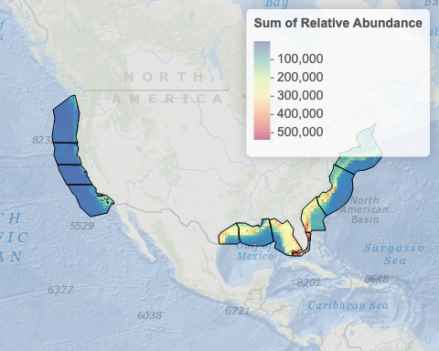

### Zone Average

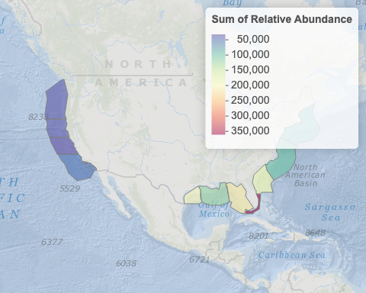

## Extinction Risk

### Pixel Value

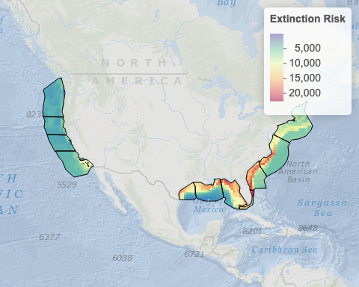

### Zone Average

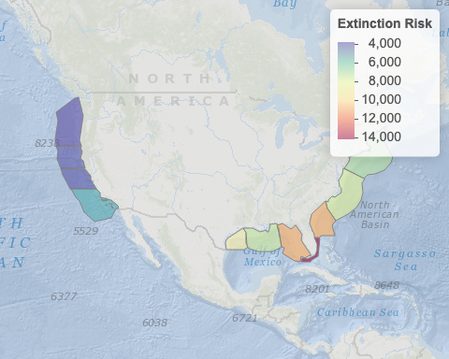

## Primary Productivity

### Pixel Value

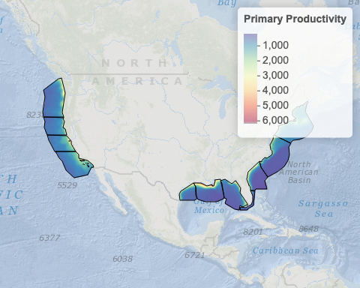

* TODO: units above (like mg C / L) and other layers

### Zone Average

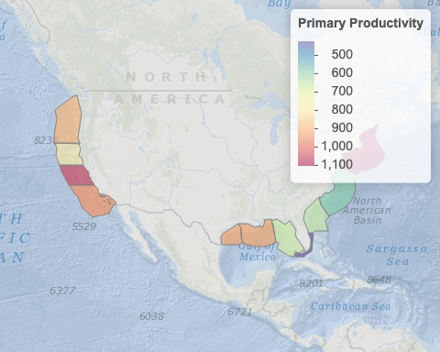

## Hydrothermal Vents

### Pixel Value

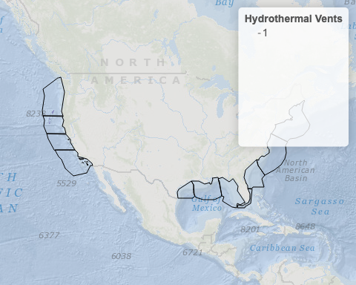

### Zone Average

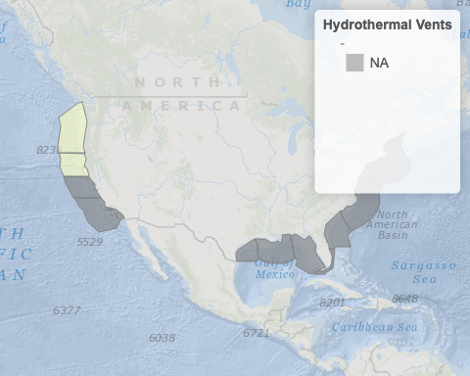

## Seamounts

### Pixel Value

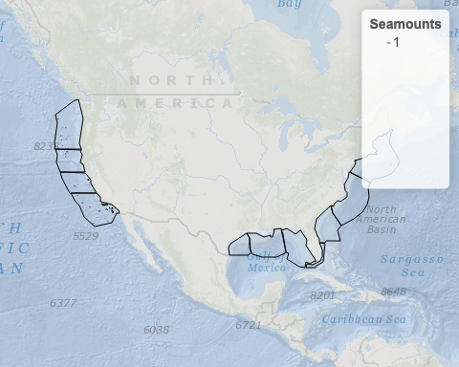

### Zone Average

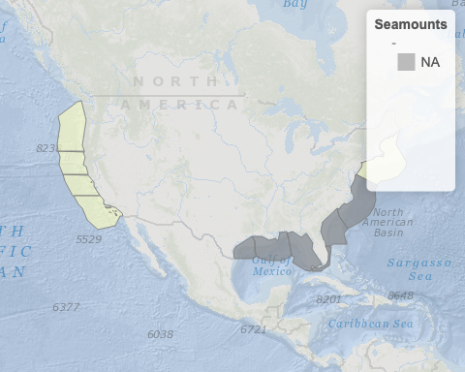

# Appendix C — Blocks

## C.1 Zones with Blocks

When zooming into the Blocks in a Zone, we look at deviation from the mean score in the Zone, so 0 is equivalent the Zone average. If the score values were normally distributed (like a bell curve) around the average, then one standard deviation (SD) above/below is about 34.1% higher/lower than the average (so 68.2% of all values), two SDs is 47.7% higher/lower than the average (so 95.4% of all values) and three SDs are the most extreme at 49.9% higher/lower (so 99.9% of all values).

### Washington/Oregon

|  |
| --- |
| Figure C.1: Interactive map of standard deviations from the average score in the zone. Fullscreen option available. |

| Type | Block | Information | Score |  | Rank | SD | plan |
| --- | --- | --- | --- | --- | --- | --- | --- |
| Planning Area | NK10-01, 6218G | Oregon Call Area - Coos Bay | 14.000 |  | 0.000% | -0.0313 |  |
| Planning Area | NK10-01, 6218K | Oregon Call Area - Coos Bay | 14.000 |  | 0.000% | -0.0313 |  |
| Planning Area | NK10-01, 6218O | Oregon Call Area - Coos Bay | 14.000 |  | 0.000% | -0.0313 |  |
| Planning Area | NK10-01, 6267P | Oregon Call Area - Coos Bay | 14.000 |  | 0.000% | -0.0313 |  |
| Planning Area | NK10-01, 6268B | Oregon Call Area - Coos Bay | 14.000 |  | 0.000% | -0.0313 |  |
|  |  |  |  |  |  |  | ...(842 rows)... |
| Planning Area | NK10-01, 6327H | Oregon Call Area - Coos Bay | 29.000 |  | 99.530% | 2.4524 |  |
| Planning Area | NL10-10, 7176P | Oregon Call Area - Coos Bay | 29.000 |  | 99.530% | 2.4524 |  |
| Planning Area | NL10-10, 7177O | Oregon Call Area - Coos Bay | 29.000 |  | 99.530% | 2.4524 |  |
| Planning Area | NL10-10, 7177P | Oregon Call Area - Coos Bay | 29.000 |  | 99.530% | 2.4524 |  |
| Planning Area | NK10-01, 6327D | Oregon Call Area - Coos Bay | 29.200 |  | 100.000% | 2.4855 |  |

### Northern California

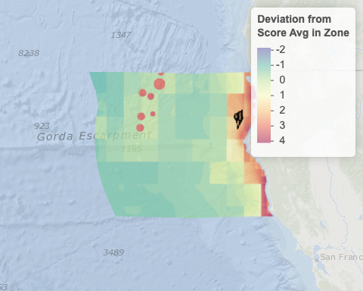

| Type | Block | Information | Score |  | Rank | SD | plan |
| --- | --- | --- | --- | --- | --- | --- | --- |
| Lease | NK10-07, 7122G | OCS-P 0562, California North Floating LLC | 22.000 |  | 0.000% | 1.6745 |  |
| Lease | NK10-07, 7122H | OCS-P 0562, California North Floating LLC | 22.000 |  | 0.000% | 1.6745 |  |
| Lease | NK10-07, 7122J | OCS-P 0562, California North Floating LLC | 22.000 |  | 0.000% | 1.6745 |  |
| Lease | NK10-07, 7122K | OCS-P 0562, California North Floating LLC | 22.000 |  | 0.000% | 1.6745 |  |
| Lease | NK10-07, 7122L | OCS-P 0562, California North Floating LLC | 22.000 |  | 0.000% | 1.6745 |  |
|  |  |  |  |  |  |  | ...(227 rows)... |
| Lease | NK10-07, 7076J | OCS-P 0561, RWE Offshore Wind Holdings, LLC | 26.000 |  | 92.797% | 2.4763 |  |
| Lease | NK10-07, 7076K | OCS-P 0561, RWE Offshore Wind Holdings, LLC | 26.000 |  | 92.797% | 2.4763 |  |
| Lease | NK10-07, 7076M | OCS-P 0561, RWE Offshore Wind Holdings, LLC | 26.000 |  | 92.797% | 2.4763 |  |
| Lease | NK10-07, 7076N | OCS-P 0561, RWE Offshore Wind Holdings, LLC | 26.000 |  | 92.797% | 2.4763 |  |
| Lease | NK10-07, 7076O | OCS-P 0561, RWE Offshore Wind Holdings, LLC | 26.000 |  | 92.797% | 2.4763 |  |

### Central California

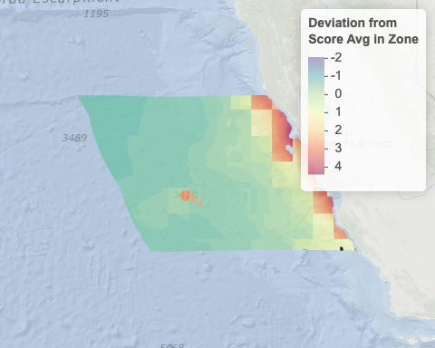

| Type | Block | Information | Score |  | Rank | SD | plan |
| --- | --- | --- | --- | --- | --- | --- | --- |
| Planning Area | NI09-03, 6102L | California Call Area - Morro Bay | 19.000 |  | 0.000% | 0.8967 |  |
| Planning Area | NI09-03, 6102P | California Call Area - Morro Bay | 19.000 |  | 0.000% | 0.8967 |  |
| Planning Area | NI09-03, 6103M | California Call Area - Morro Bay | 19.000 |  | 0.000% | 0.8967 |  |
| Planning Area | NI09-03, 6152D | California Call Area - Morro Bay | 19.000 |  | 0.000% | 0.8967 |  |
| Planning Area | NI09-03, 6152L | California Call Area - Morro Bay | 19.000 |  | 0.000% | 0.8967 |  |
|  |  |  |  |  |  |  | ...(6 rows)... |
| Planning Area | NI09-03, 6153J | California Call Area - Morro Bay | 19.000 |  | 0.000% | 0.8967 |  |
| Planning Area | NI09-03, 6153K | California Call Area - Morro Bay | 19.000 |  | 0.000% | 0.8967 |  |
| Planning Area | NI09-03, 6153M | California Call Area - Morro Bay | 19.000 |  | 0.000% | 0.8967 |  |
| Planning Area | NI09-03, 6153N | California Call Area - Morro Bay | 19.000 |  | 0.000% | 0.8967 |  |
| Planning Area | NI09-03, 6153O | California Call Area - Morro Bay | 19.000 |  | 0.000% | 0.8967 |  |

### Southern California

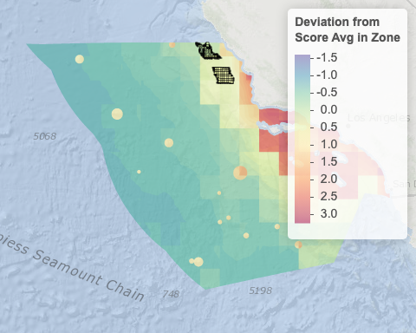

| Type | Block | Information | Score |  | Rank | SD | plan |
| --- | --- | --- | --- | --- | --- | --- | --- |
| Lease | NI10-02, 6237C | OCS-P 0563, Equinor wind US LLC | 18.000 |  | 0.000% | -0.0240 |  |
| Lease | NI10-02, 6237D | OCS-P 0563, Equinor wind US LLC | 18.000 |  | 0.000% | -0.0240 |  |
| Lease | NI10-02, 6237H | OCS-P 0563, Equinor wind US LLC | 18.000 |  | 0.000% | -0.0240 |  |
| Lease | NI10-02, 6237L | OCS-P 0563, Equinor wind US LLC | 18.000 |  | 0.000% | -0.0240 |  |
| Lease | NI10-02, 6237P | OCS-P 0563, Equinor wind US LLC | 18.000 |  | 0.000% | -0.0240 |  |
|  |  |  |  |  |  |  | ...(663 rows)... |
| Planning Area | NI10-03, 7016I | California Call Area - Diablo Canyon | 26.000 |  | 98.363% | 0.8163 |  |
| Planning Area | NI10-03, 7016M | California Call Area - Diablo Canyon | 26.000 |  | 98.363% | 0.8163 |  |
| Planning Area | NI10-03, 7066A | California Call Area - Diablo Canyon | 26.000 |  | 98.363% | 0.8163 |  |
| Planning Area | NI10-03, 7066E | California Call Area - Diablo Canyon | 26.000 |  | 98.363% | 0.8163 |  |
| Planning Area | NI10-03, 7066I | California Call Area - Diablo Canyon | 26.000 |  | 98.363% | 0.8163 |  |

### Western Gulf of Mexico

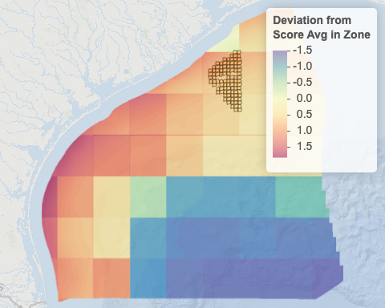

| Type | Block | Information | Score |  | Rank | SD | plan |
| --- | --- | --- | --- | --- | --- | --- | --- |
| Planning Area | NH15-10, 6782 | Gulf of Mexico WEA | 53.052 |  | 0.000% | 0.4779 |  |
| Planning Area | NH15-10, 6732 | Gulf of Mexico WEA | 53.282 |  | 1.053% | 0.4885 |  |
| Planning Area | NH15-10, 6682 | Gulf of Mexico WEA | 53.741 |  | 2.105% | 0.5096 |  |
| Planning Area | NH15-10, 6632 | Gulf of Mexico WEA | 54.000 |  | 3.158% | 0.5216 |  |
| Planning Area | NH15-07, 7130 | Gulf of Mexico WEA | 54.061 |  | 4.211% | 0.5244 |  |
|  |  |  |  |  |  |  | ...(86 rows)... |
| Planning Area | NH15-10, 6175 | Gulf of Mexico WEA | 61.859 |  | 95.789% | 0.8832 |  |
| Planning Area | NH15-10, 6031 | Gulf of Mexico WEA | 61.915 |  | 96.842% | 0.8858 |  |
| Planning Area | NH15-10, 6078 | Gulf of Mexico WEA | 62.000 |  | 97.895% | 0.8897 |  |
| Planning Area | NH15-10, 6030 | Gulf of Mexico WEA | 62.025 |  | 98.947% | 0.8908 |  |
| Planning Area | NH15-10, 6126 | Gulf of Mexico WEA | 62.136 |  | 100.000% | 0.8959 |  |

### Central Gulf of Mexico

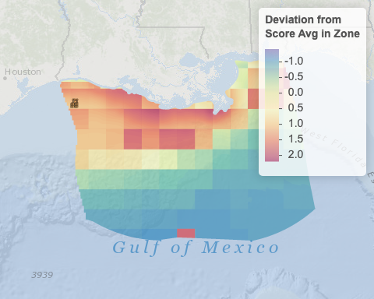

| Type | Block | Information | Score |  | Rank | SD | plan |
| --- | --- | --- | --- | --- | --- | --- | --- |
| Lease | NH15-08, 7062 | OCS-G 37334 - Provisional, NA | 52.000 |  | 0.000% | 0.9553 |  |
| Lease | NH15-08, 7063 | OCS-G 37334 - Provisional, NA | 52.000 |  | 0.000% | 0.9553 |  |
| Lease | NH15-08, 7064 | OCS-G 37334 - Provisional, NA | 52.000 |  | 0.000% | 0.9553 |  |
| Lease | NH15-08, 7061 | OCS-G 37334 - Provisional, RWE Offshore US Gulf, LLC | 52.025 |  | 17.647% | 0.9564 |  |
| Lease | NH15-08, 7014 | OCS-G 37334 - Provisional, NA | 52.556 |  | 23.529% | 0.9805 |  |
|  |  |  |  |  |  |  | ...(8 rows)... |
| Lease | NH15-08, 6913 | OCS-G 37334 - Provisional, NA | 54.469 |  | 76.471% | 1.0672 |  |
| Lease | NH15-08, 6912 | OCS-G 37334 - Provisional, NA | 54.556 |  | 82.353% | 1.0711 |  |
| Lease | NH15-08, 6864 | OCS-G 37334 - Provisional, NA | 55.333 |  | 88.235% | 1.1064 |  |
| Lease | NH15-08, 6863 | OCS-G 37334 - Provisional, NA | 55.395 |  | 94.118% | 1.1092 |  |
| Lease | NH15-08, 6862 | OCS-G 37334 - Provisional, NA | 55.432 |  | 100.000% | 1.1109 |  |

### South Atlantic

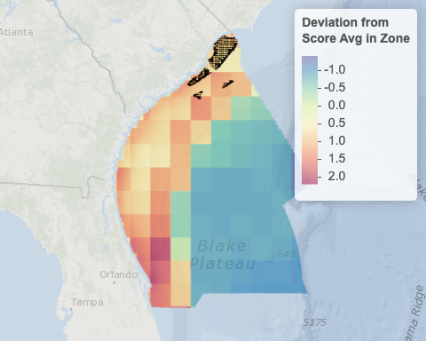

| Type | Block | Information | Score |  | Rank | SD | plan |
| --- | --- | --- | --- | --- | --- | --- | --- |
| Planning Area | NI17-09, 6578B | South Carolina Call Area - Grand Strand | 54.000 |  | 0.000% | 0.5656 |  |
| Planning Area | NI17-09, 6578C | South Carolina Call Area - Grand Strand | 54.000 |  | 0.000% | 0.5656 |  |
| Planning Area | NI17-09, 6578D | South Carolina Call Area - Grand Strand | 54.000 |  | 0.000% | 0.5656 |  |
| Planning Area | NI17-09, 6578F | South Carolina Call Area - Grand Strand | 54.000 |  | 0.000% | 0.5656 |  |
| Planning Area | NI17-09, 6578G | South Carolina Call Area - Grand Strand | 54.000 |  | 0.000% | 0.5656 |  |
|  |  |  |  |  |  |  | ...(791 rows)... |
| Planning Area | NI17-12, 6564K | South Carolina Call Area - Charleston | 74.000 |  | 97.875% | 1.4399 |  |
| Planning Area | NI17-12, 6564L | South Carolina Call Area - Charleston | 74.000 |  | 97.875% | 1.4399 |  |
| Planning Area | NI17-12, 6564O | South Carolina Call Area - Charleston | 74.000 |  | 97.875% | 1.4399 |  |
| Planning Area | NI17-12, 6563B | South Carolina Call Area - Charleston | 74.833 |  | 99.875% | 1.4763 |  |
| Planning Area | NI17-12, 6512P | South Carolina Call Area - Charleston | 75.000 |  | 100.000% | 1.4836 |  |

### Mid Atlantic

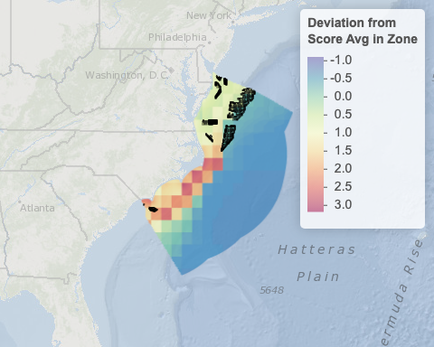

| Type | Block | Information | Score |  | Rank | SD | plan |
| --- | --- | --- | --- | --- | --- | --- | --- |
| Planning Area | NJ18-11, 6590I | Central Atlantic Call Area F | 17.000 |  | 0.000% | -0.4618 |  |
| Planning Area | NJ18-11, 6590M | Central Atlantic Call Area F | 17.000 |  | 0.000% | -0.4618 |  |
| Planning Area | NJ18-11, 6590E | Central Atlantic Call Area F | 17.667 |  | 0.079% | -0.4267 |  |
| Planning Area | NJ18-06, 7018A | Central Atlantic Call Area E | 18.000 |  | 0.119% | -0.4092 |  |
| Planning Area | NJ18-06, 7018E | Central Atlantic Call Area E | 18.000 |  | 0.119% | -0.4092 |  |
|  |  |  |  |  |  |  | ...(2512 rows)... |
| Lease | NI18-07, 6503H | OCS-A 0546, Duke Energy Renewables Wind, LLC | 68.500 |  | 99.722% | 2.2500 |  |
| Lease | NI18-07, 6503A | OCS-A 0546, Duke Energy Renewables Wind, LLC | 69.000 |  | 99.881% | 2.2763 |  |
| Lease | NI18-07, 6503B | OCS-A 0546, Duke Energy Renewables Wind, LLC | 69.000 |  | 99.881% | 2.2763 |  |
| Lease | NI18-07, 6503C | OCS-A 0546, Duke Energy Renewables Wind, LLC | 69.000 |  | 99.881% | 2.2763 |  |
| Lease | NI18-07, 6503D | OCS-A 0546, Duke Energy Renewables Wind, LLC | 69.000 |  | 99.881% | 2.2763 |  |

### North Atlantic

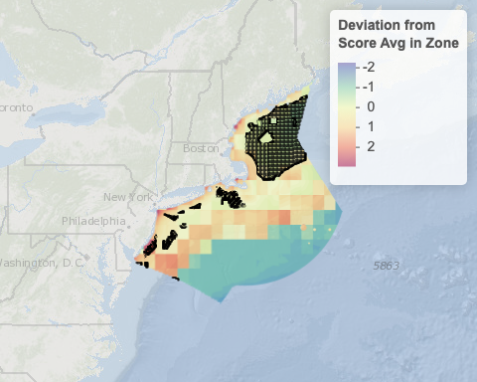

| Type | Block | Information | Score |  | Rank | SD | plan |
| --- | --- | --- | --- | --- | --- | --- | --- |
| Planning Area | NJ18-06, 6917O | Central Atlantic Call Area E | 18.000 |  | 0.000% | -1.1212 |  |
| Planning Area | NJ18-06, 6917P | Central Atlantic Call Area E | 18.000 |  | 0.000% | -1.1212 |  |
| Planning Area | NJ18-06, 6918M | Central Atlantic Call Area E | 18.000 |  | 0.000% | -1.1212 |  |
| Planning Area | NJ18-06, 6968A | Central Atlantic Call Area E | 18.000 |  | 0.000% | -1.1212 |  |
| Planning Area | NJ18-06, 6968E | Central Atlantic Call Area E | 18.000 |  | 0.000% | -1.1212 |  |
|  |  |  |  |  |  |  | ...(6353 rows)... |
| Lease | NJ18-02, 6833F | OCS-A 0532, Orsted North America Inc. | 47.000 |  | 99.921% | 2.4548 |  |
| Lease | NJ18-02, 6833I | OCS-A 0532, Orsted North America Inc. | 47.000 |  | 99.921% | 2.4548 |  |
| Lease | NJ18-02, 6833J | OCS-A 0532, Orsted North America Inc. | 47.000 |  | 99.921% | 2.4548 |  |
| Lease | NJ18-02, 6833M | OCS-A 0532, Orsted North America Inc. | 47.000 |  | 99.921% | 2.4548 |  |
| Lease | NJ18-02, 6932A | OCS-A 0532, Orsted North America Inc. | 47.000 |  | 99.921% | 2.4548 |  |